https://2nurfmnews.blogspot.com/2021/11/draft-plans-released-for-munibung-hill.html

Thursday, 11 November 2021

Draft Plans Released for Munibung Hill
BY CHARLOTTE LLOYD
Lake Macquarie's Munibung Hill's 10 year draft plan has been released for possible community accessibility and future resources.
Lake Macquarie City Council is set to use this plan as a draft for future management in order to successfully capitalise on the precinct by both keeping with community interest while seeking tourists to the area.
The 130ha plan combines suburbs of Macquarie Hills, Boolaroo, Speers Point, Warners Bay and Lakelands.
Some of the proposed changes are within the limitations of upholding the environmental and cultural values of the site while enhancing the use of the hill.
Manager of Community Assets at Lake Macquarie Council Brendan Callander said he is confident in maintain the sites untouched beauty while being able to add things such as; off-road parking, picnic tables, signage and toilets, all of which are lacking from the much-loved site.
“Anyone who has made the climb to the top would agree this is one of the Hunter Region’s best-kept secrets. The views of the lake, the Watagans and across the city’s suburbs are incredible.”
Out of the 15 key objectives outlined over the next 10 years include;
- Making walking tracks safe and stable.
- Protecting Aboriginal cultural values and ecological communities.
- Restricting vehicle access to essential services and emergency vehicles.
- Ensure activities provide public benefits, not private benefits.
- Increasing the number of people visiting the area.

Lake Macquarie Council are seeking feedback on the plan which will be on public exhibition until December 20 2021.

An in-person information session will also be taking place at the Council's Speers Point administration building on November 24 from 5.20pm-6.30pm and an online session November 30 from 1-2pm.

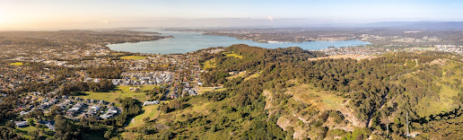
360 Degree View of Munibung Hill View
Posted by 2NURFM News at 08:12
Email ThisBlogThis!Share to TwitterShare to FacebookShare to Pinterest
Labels: 10YearPlan, 2NURFM, DraftPlan, hunterlocalnews, lakemacquarie, MunibungHill

